1. Domain users. Try the following practices.

a) Add a user "test1" to the domain that has to change the password after the first logging. Try to log in.

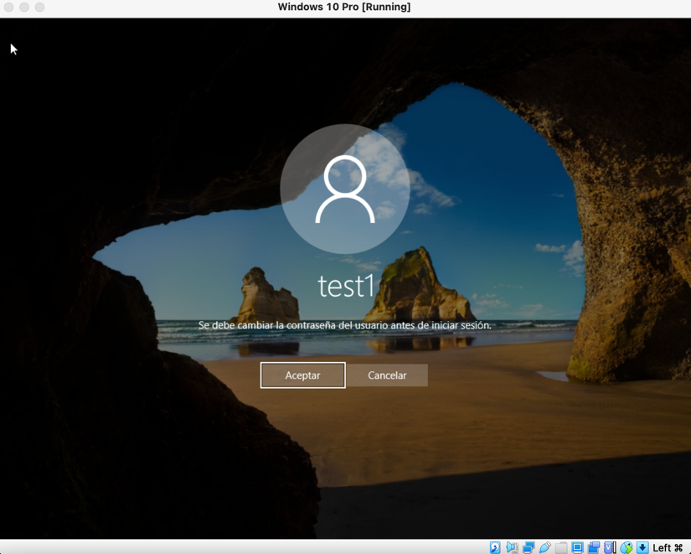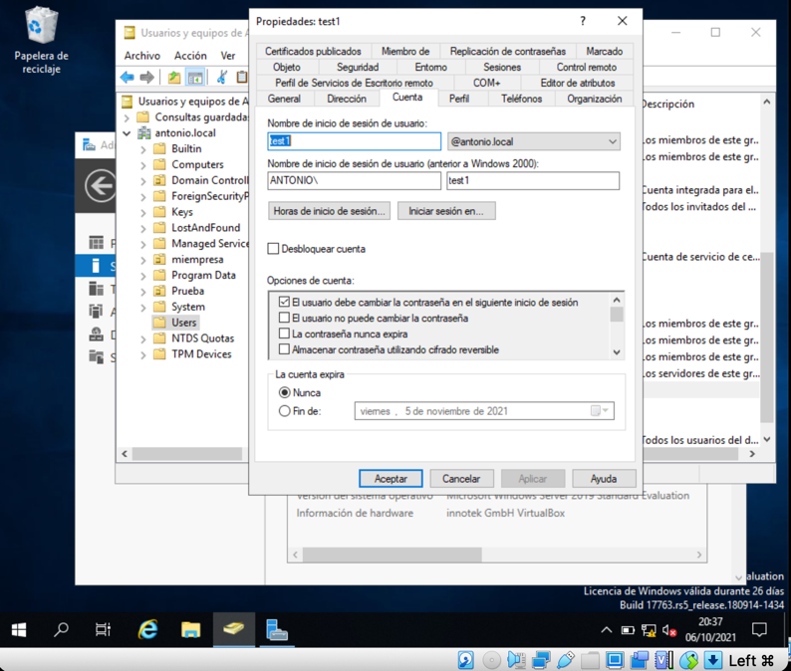

b) Add a user "test2" to the domain whose password never expires. Try to log in.

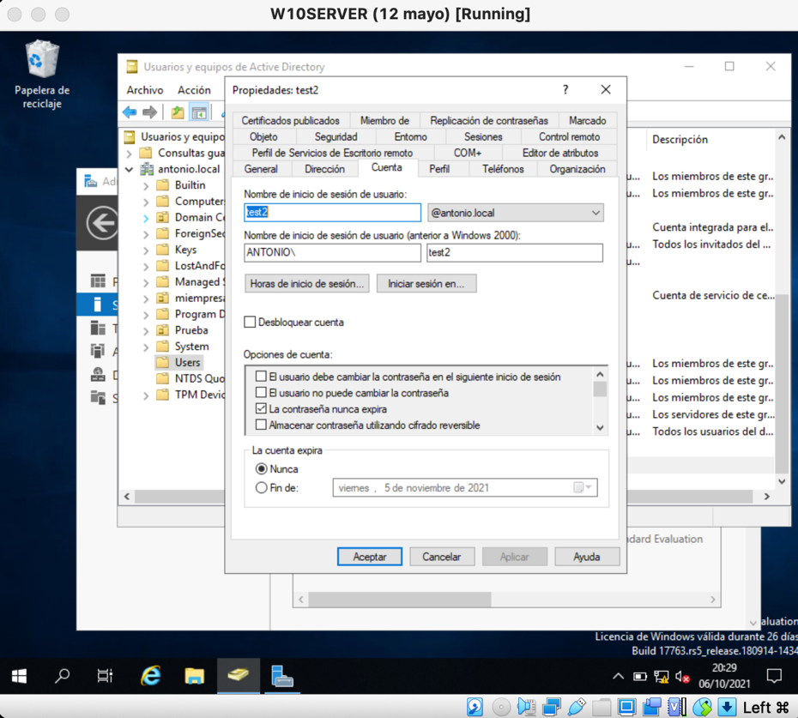

c) Add a user "test3" whose account is disabled. Try to log in.

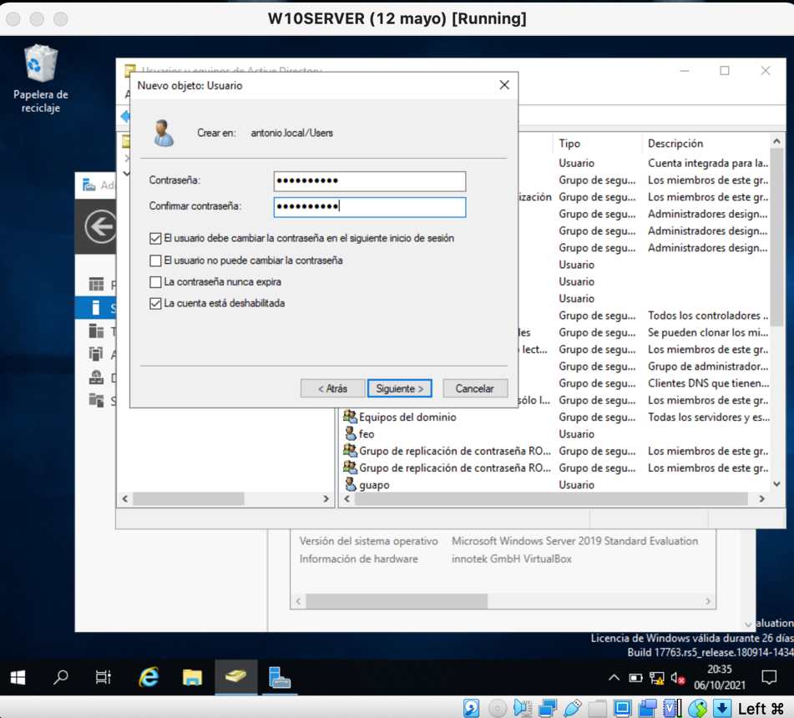

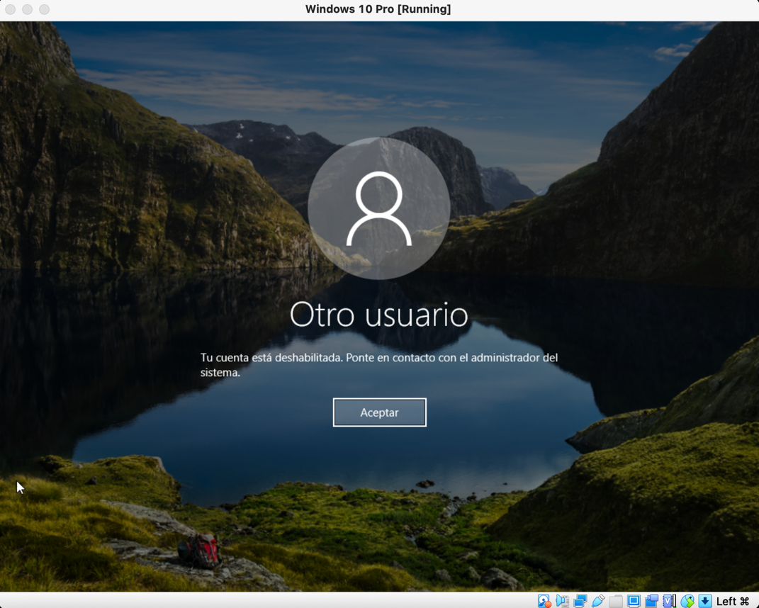

d) Add a user “test4” with no password. Try to log in.

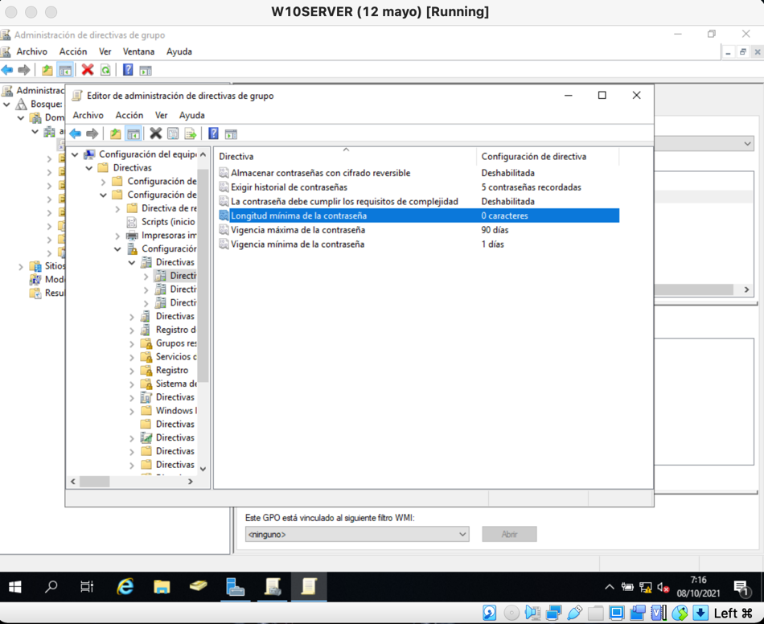

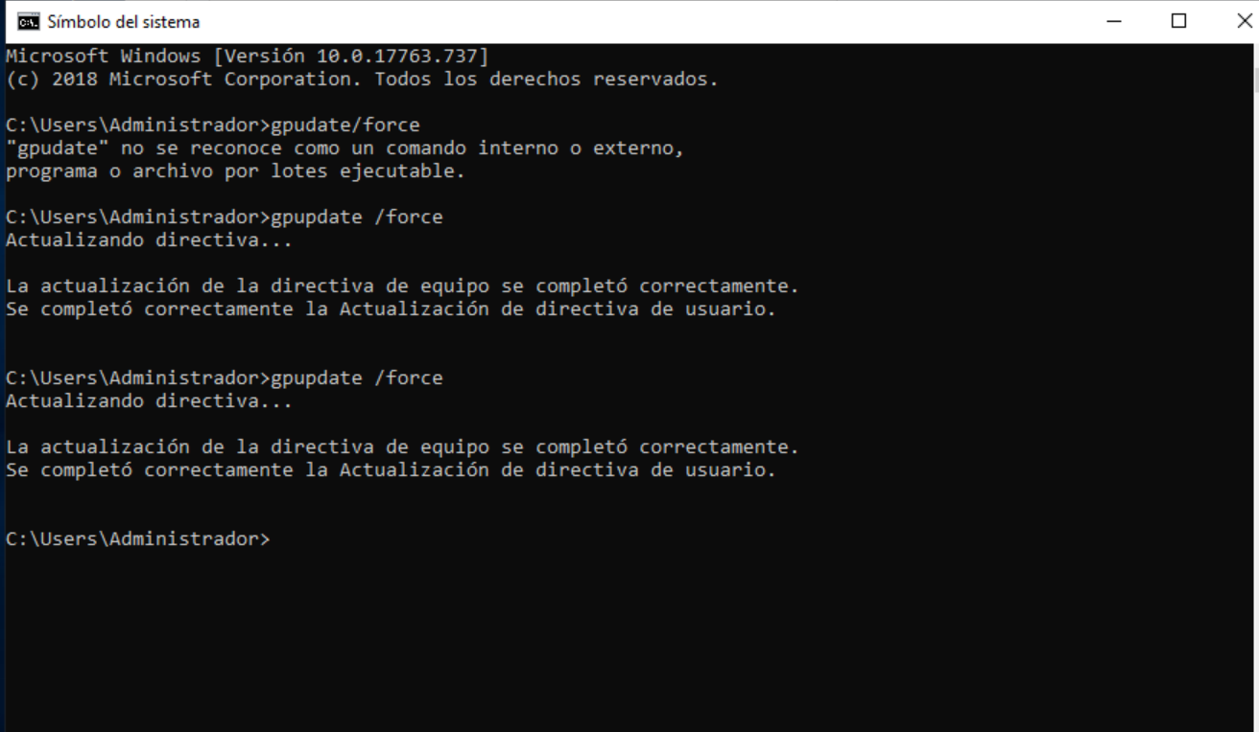

e) Add a user “test5” that can only log into the system from 9 am to 1 pm. Try to log in.

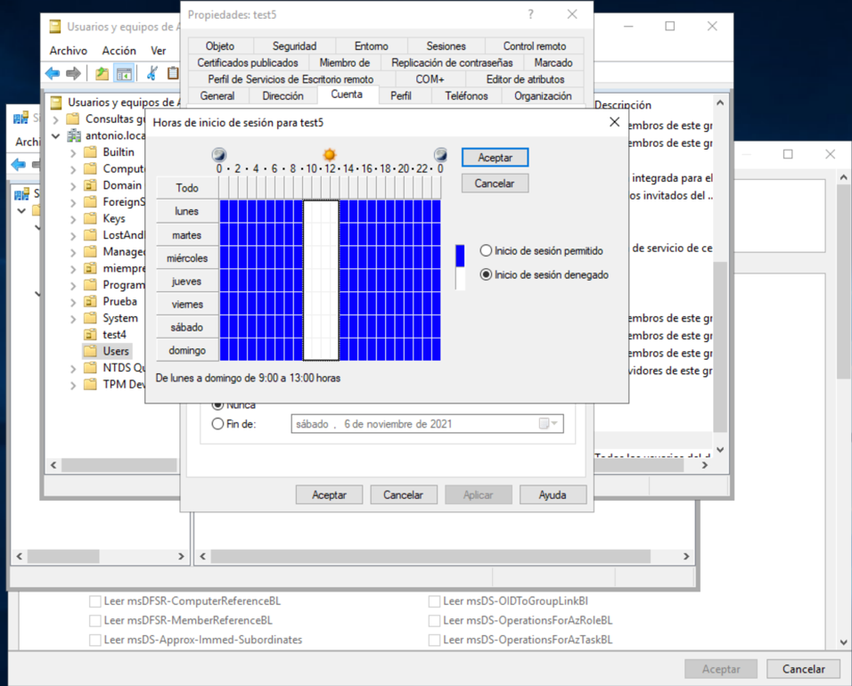

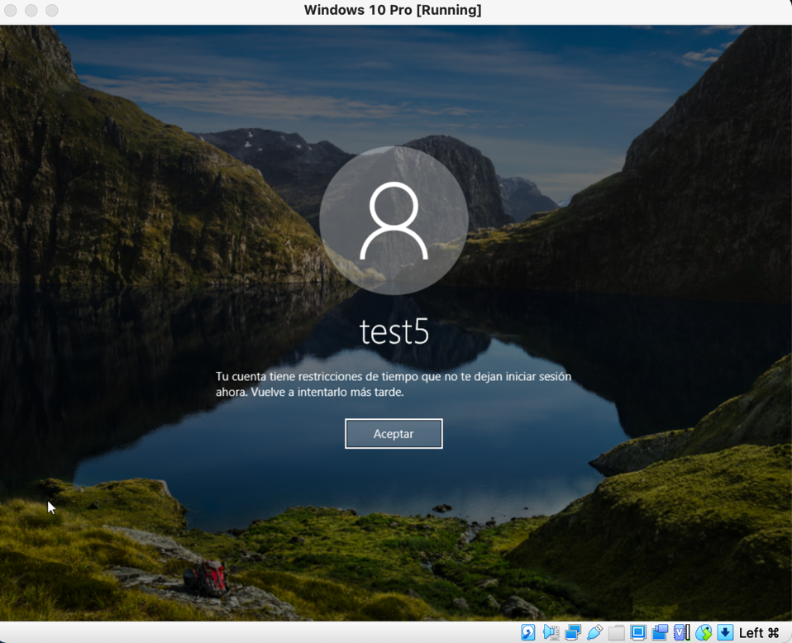

f) Add a user “test6” copying the user “test5”. Try to log in. Does the user has the same

restriction test6 had?.

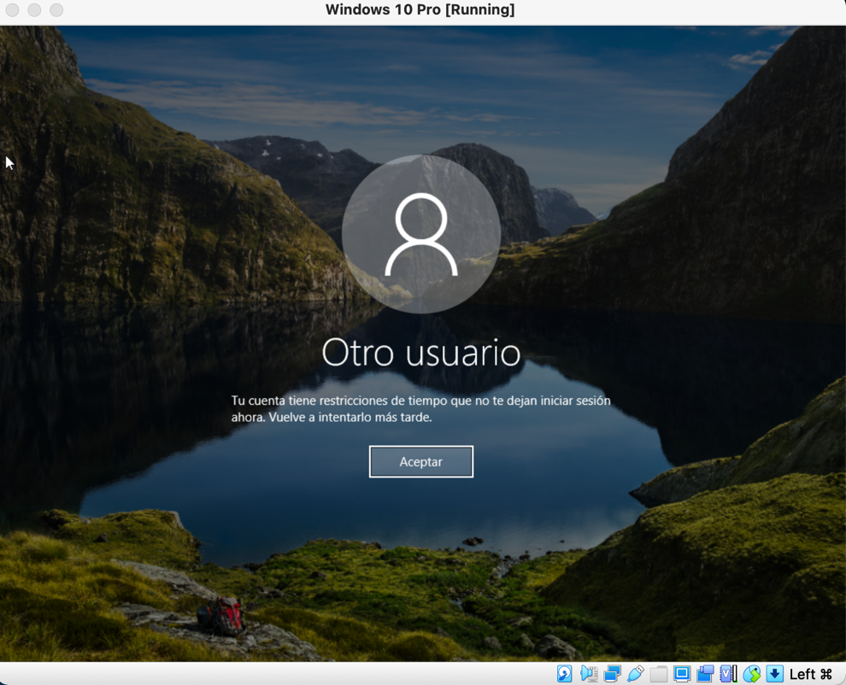

Yes, test 6 has the same restrictions as test 5

g) Add a user "test7" to the domain that can only log on in a computer which name is

W10Client.

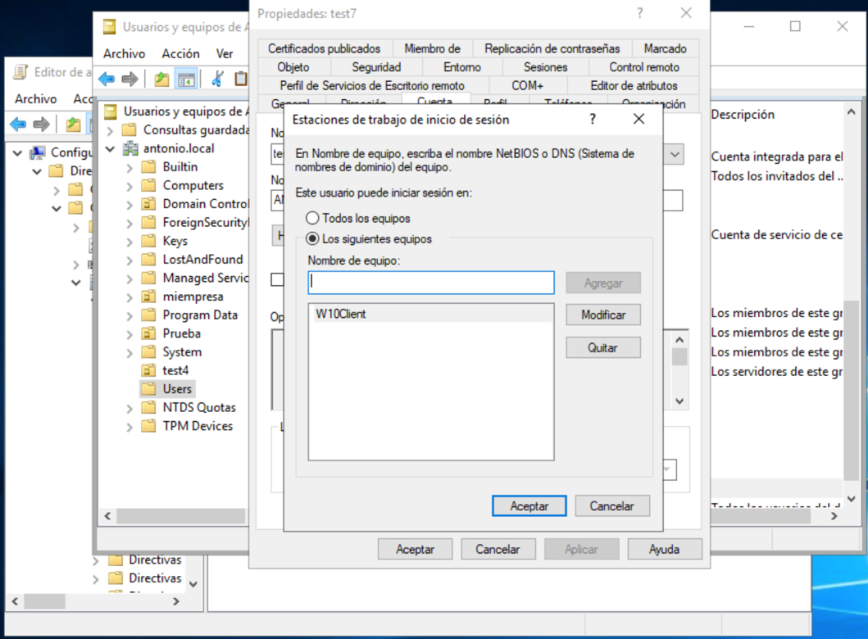

Try to log in. If your client hasn't got this name try to log in and report the error message.

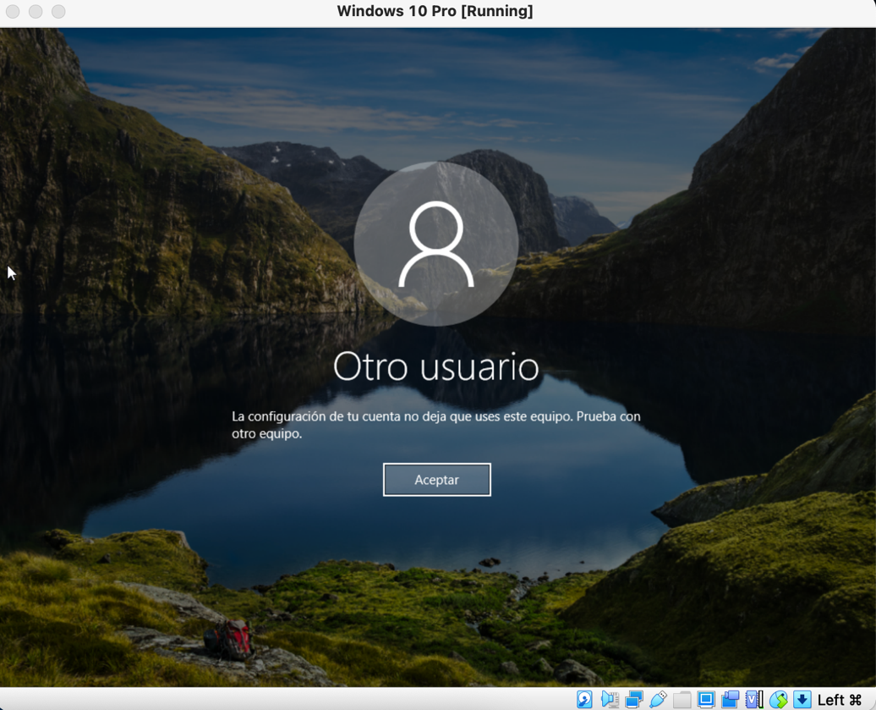

h) Add a user "test9" to the domain, prevent it from accidental deletion. Try to delete it.

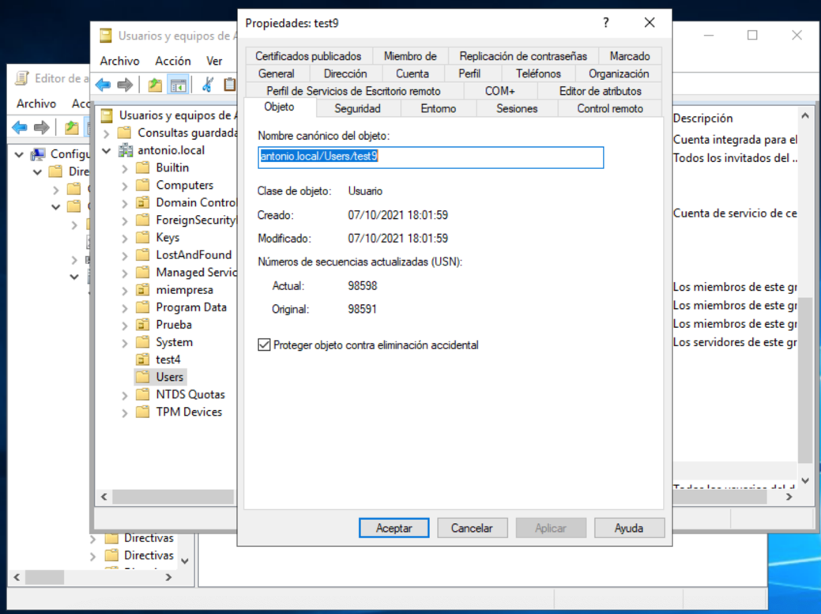

i) Add a new group “test users” with all the users previously created.

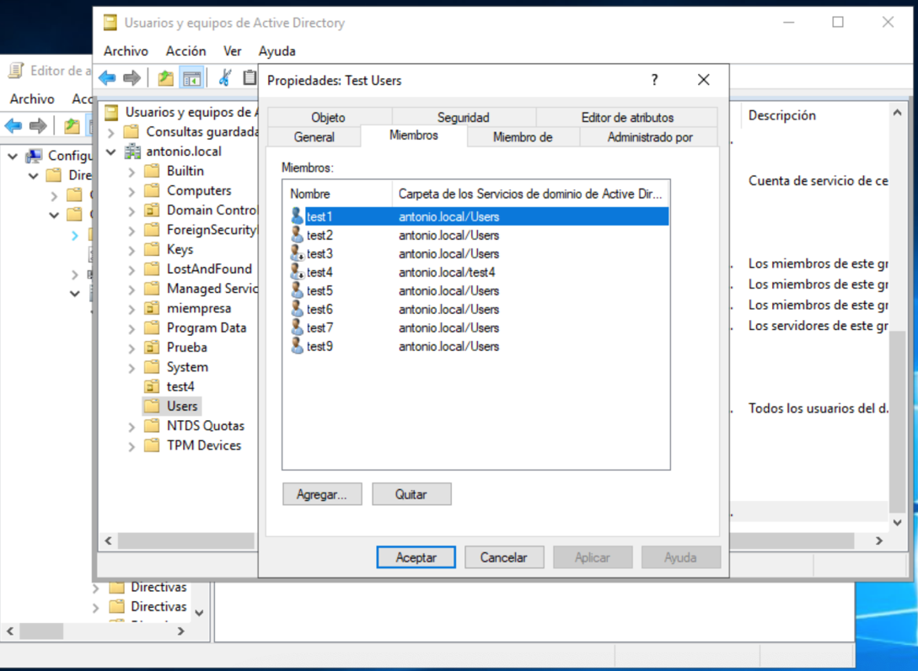

2. Organizational Units. Try the following practices.

a) Create a new OU “MY_COMPANY” .Within this OU you have to create 3 OUs, whose names are, SERVERS, PCS, COMPANY_USERS. Besides, you must create 3 OUs per each OU.

MY_COMPANY:

- SERVERS:

- ALICANTE_SERVERS

- VALENCIA_SERVERS

- CASTELLON_SERVERS

- PCS:

- ALICANTE_PCS

- VALENCIA_PCS

- CASTELLON_PCS

- COMPANY_USERS:

- ALICANTE_USERS

- VALENCIA_USERS

- CASTELLON_USERS

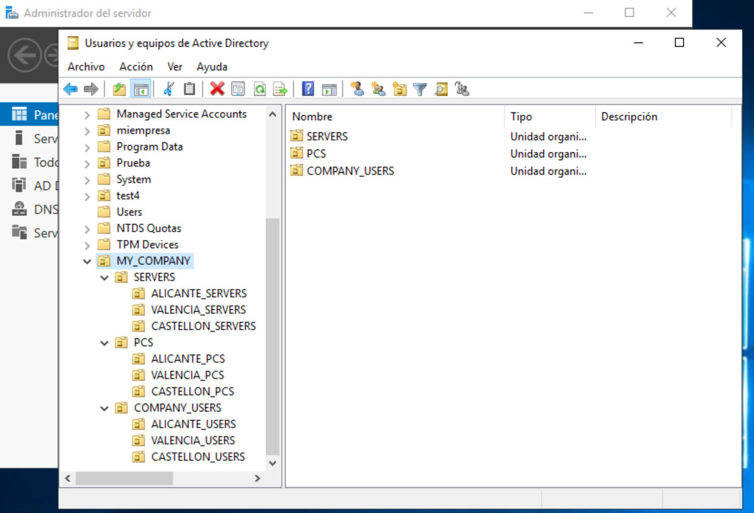

b) Add 1 computer to ALICANTE_ PCS and deploy software installation using GPO. You have to install the last Firefox version on them by this policy. Pay attention on share and folder permissions.

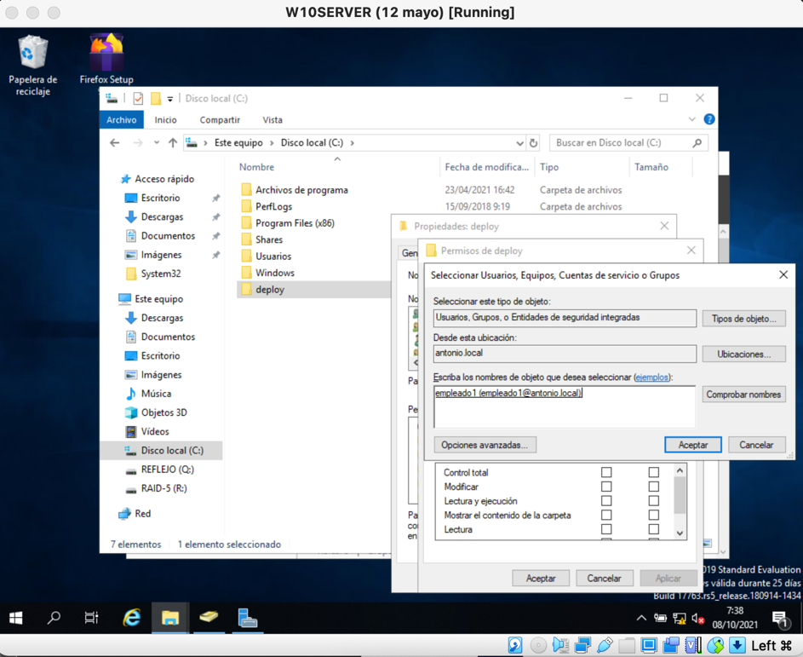

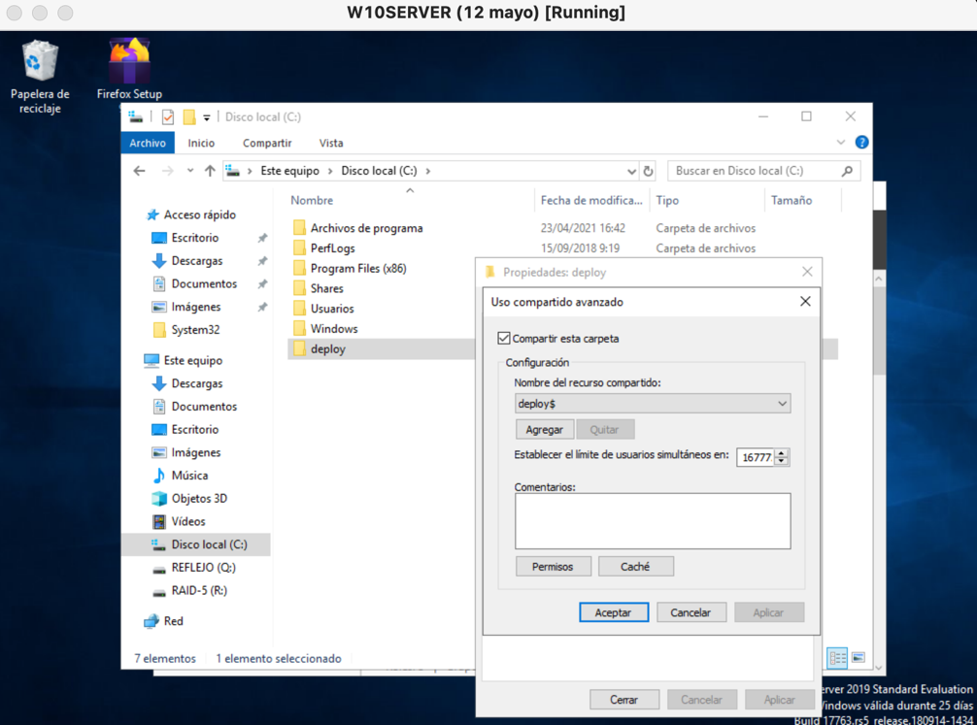

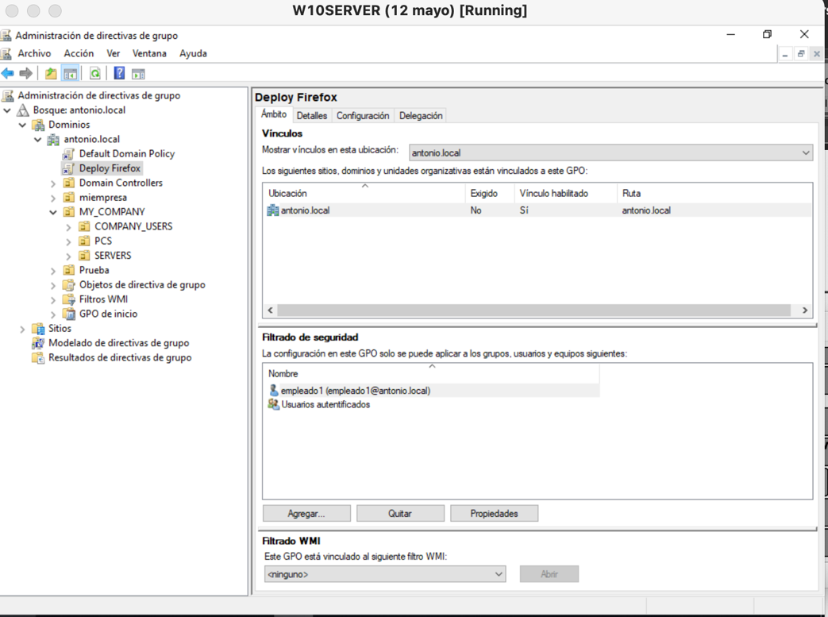

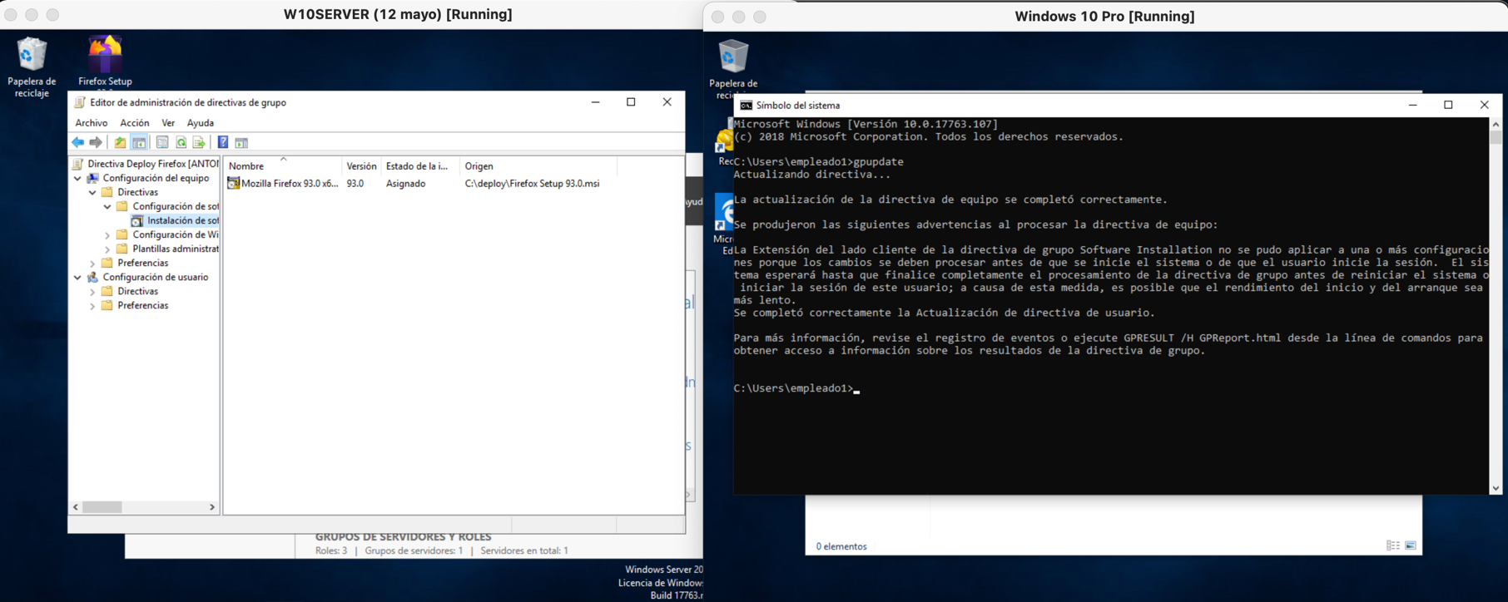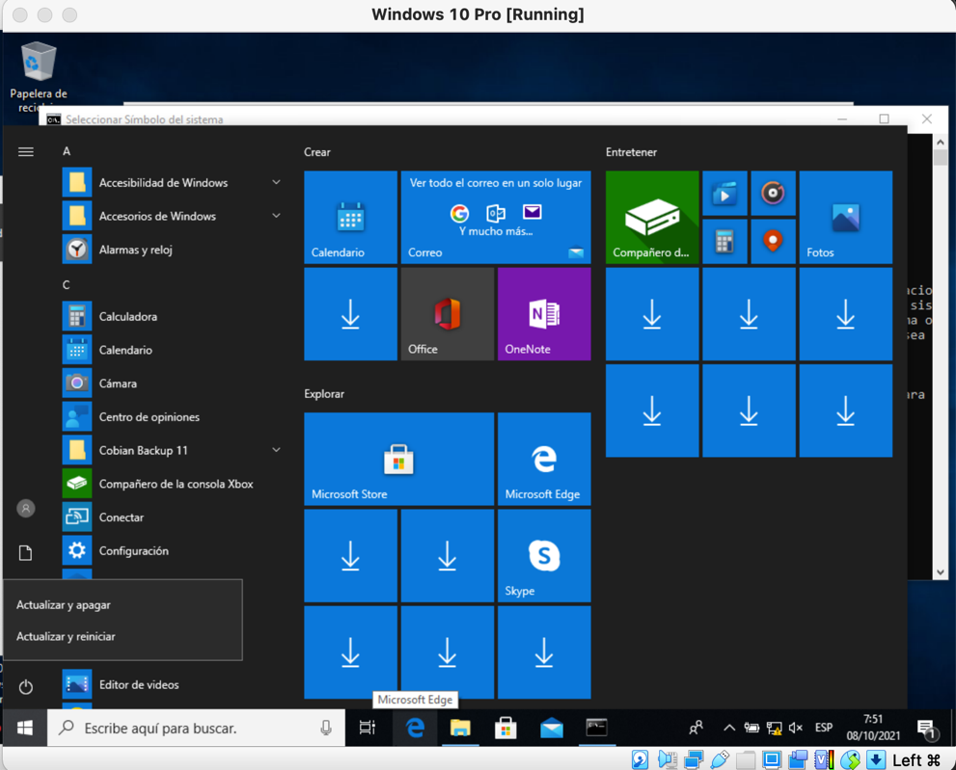

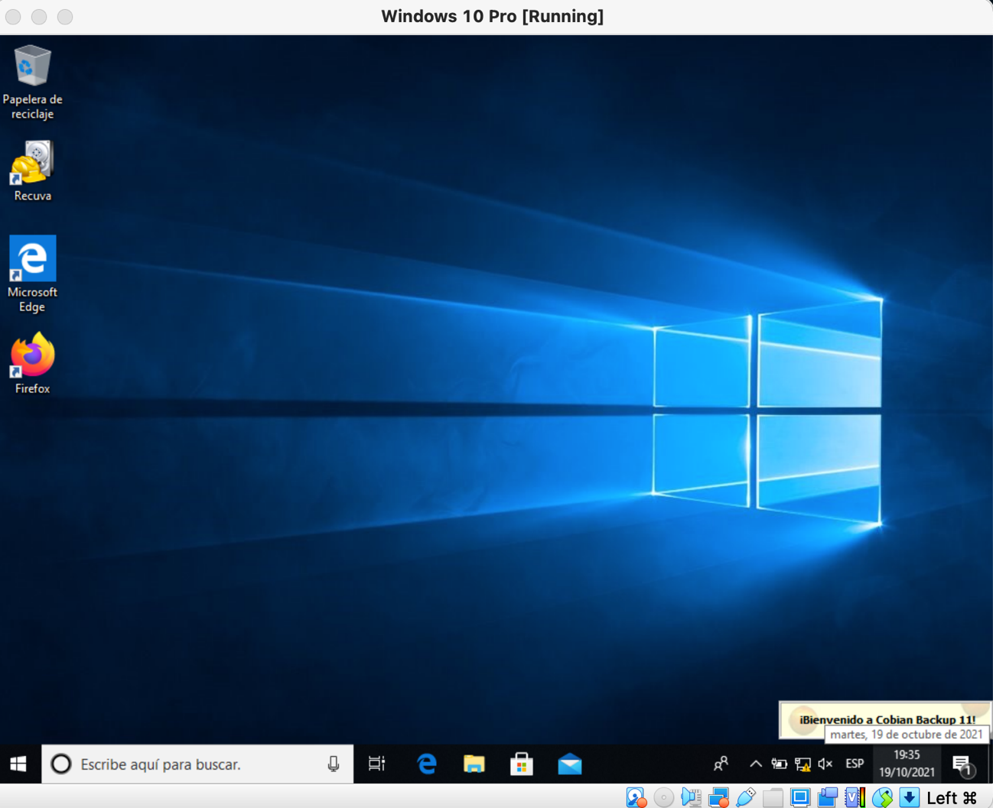

c)Add 1 user to VALENCIA_USERS for log on script examples. Write down a simple windows script to show a message, echo “Hello World”, and save if into a file. Set up a GPO where the OU users will see how this script runs while they log on.

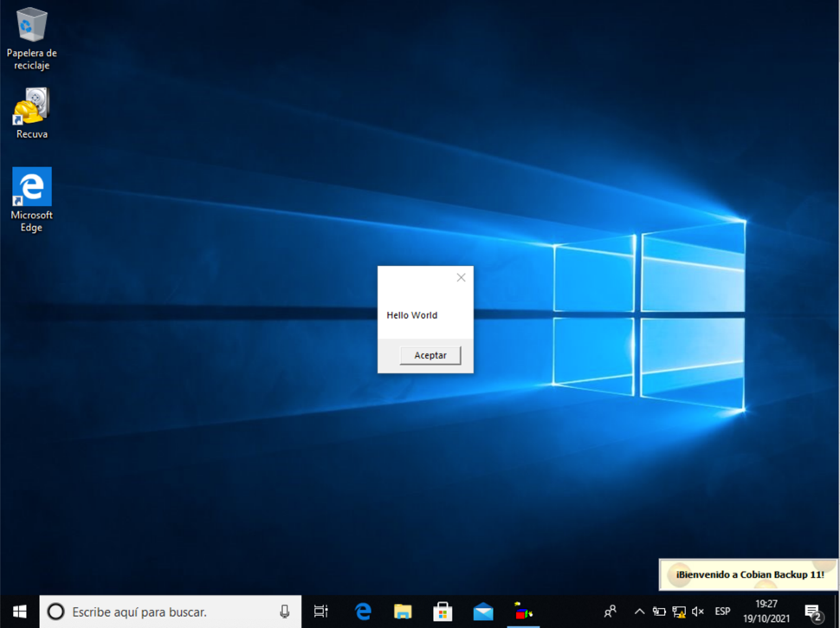

d)We are going to change different computer policies:

- Configure Automatic Updates : Select option 4 and set the schedule to every

fryday at 12:00 pm.

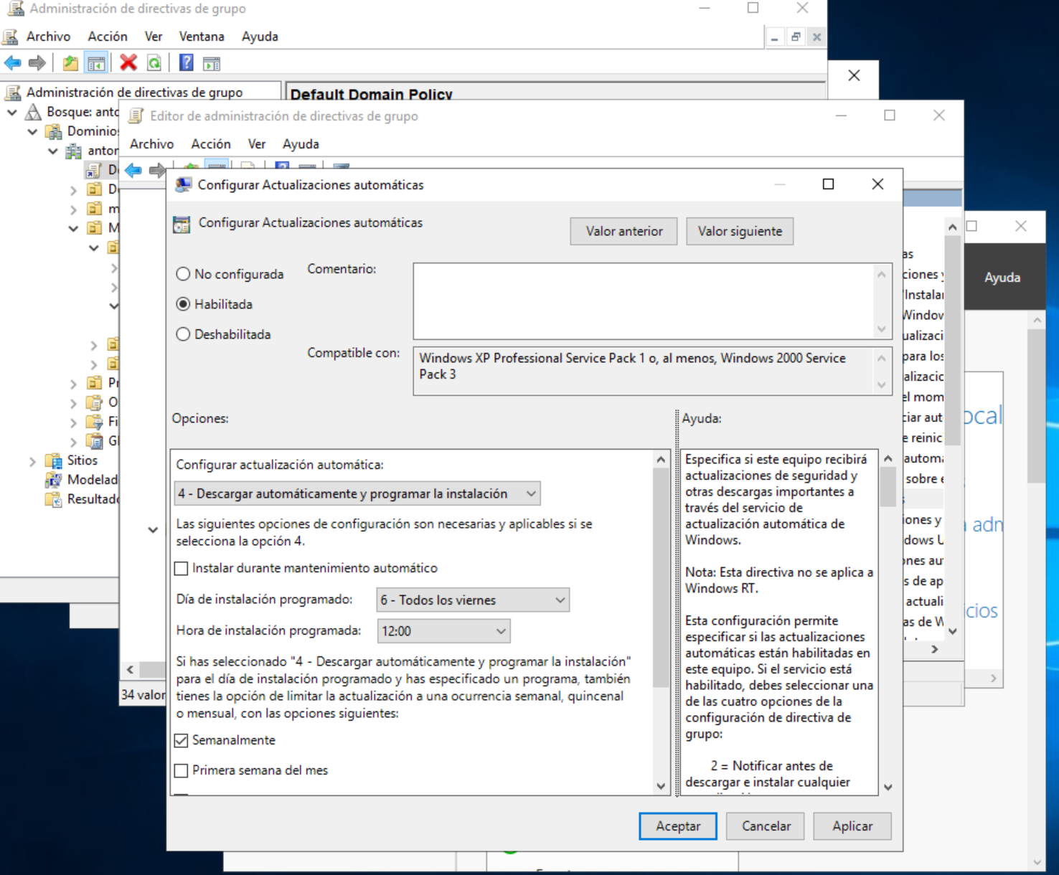

e) We are going to change different user policies:

- Set the documents redirection to a share folder on the server.

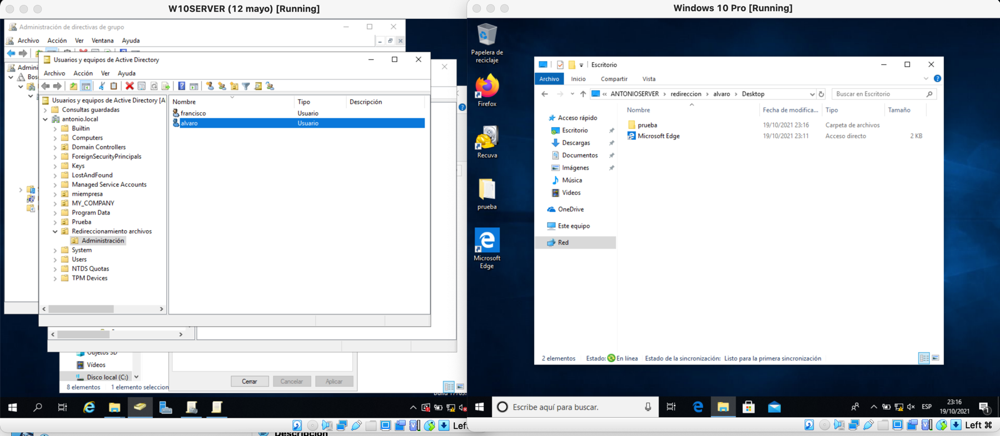

3. Checking Inheritance and enforcement. We are going to create 2 news OU “Level1_OU” and “Level2_OU”, the second one must be inside the first one.

-Level1_OU

-Level2_OU

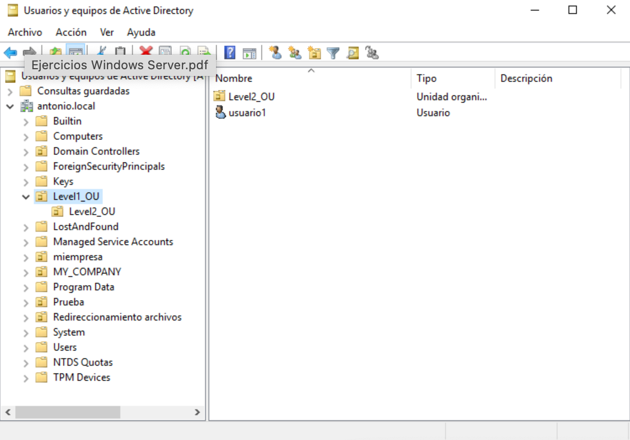

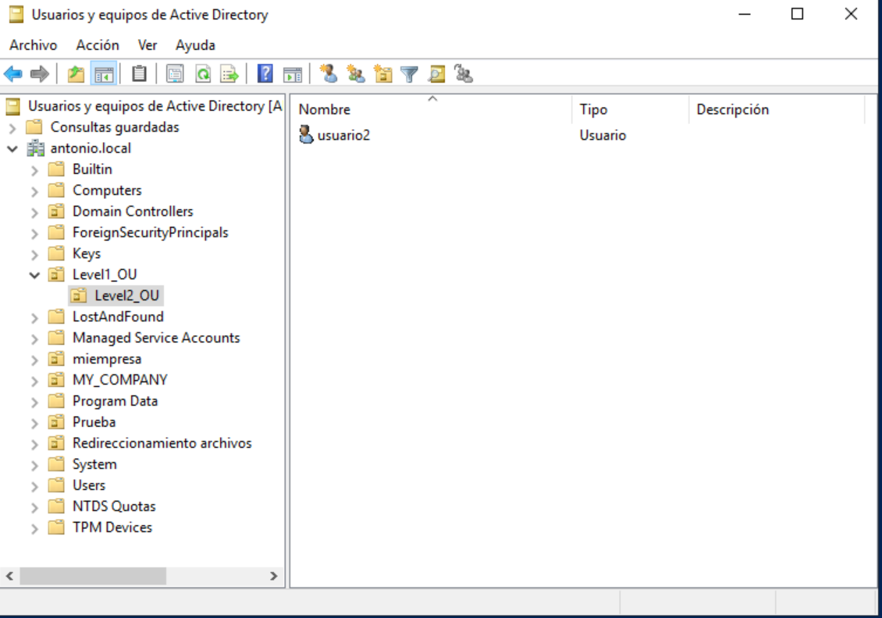

We are going to set the same policy for both OU, Desktop Wallpaper. You have to create two jpg files for both wallpapers.

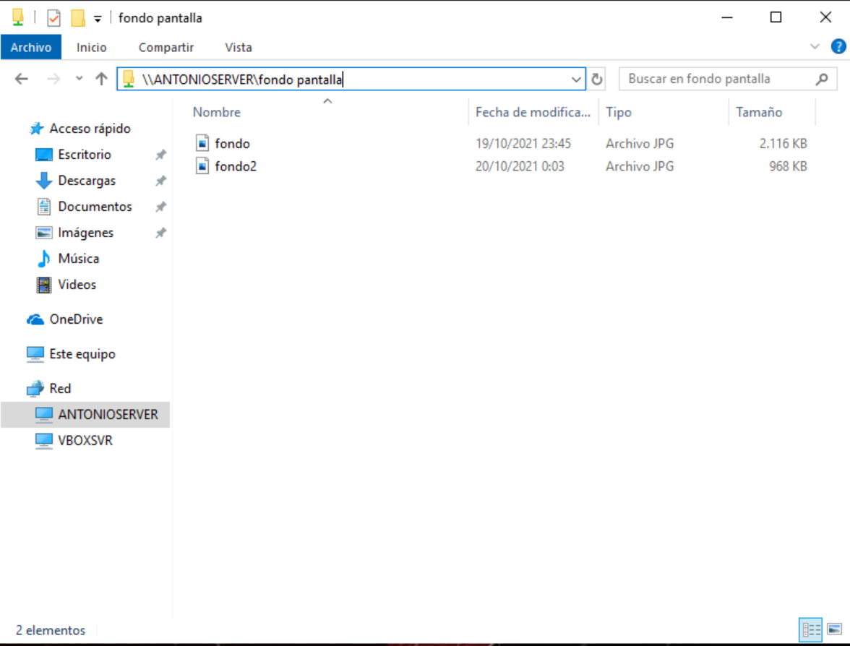

Log on with OU users and check out how inherintance and enforcement works. Beaware of update both policies and in the client also to activate policies results

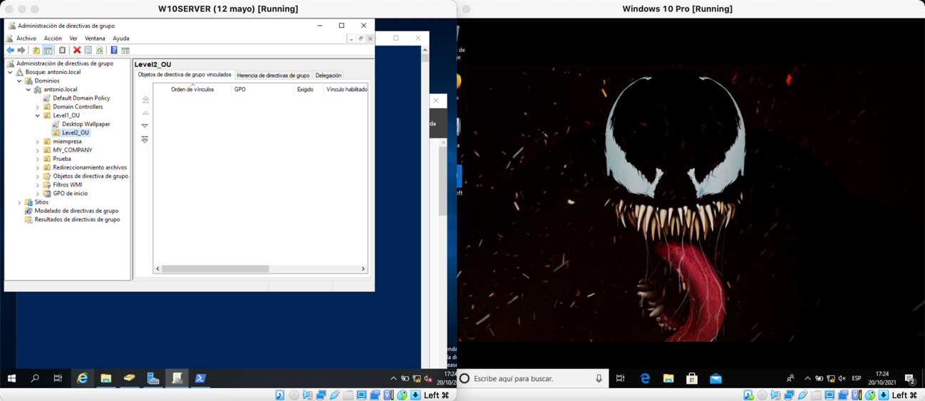

4. File services. We are going to create a share folder with subfolders, each one per user, we are only going to manage permisions. Use the network share create policy to set the folder but you can manage permisions directly in the server. Each user will be only granted to his folder. We also will create an exchange folder where all the users will have permission to get in.

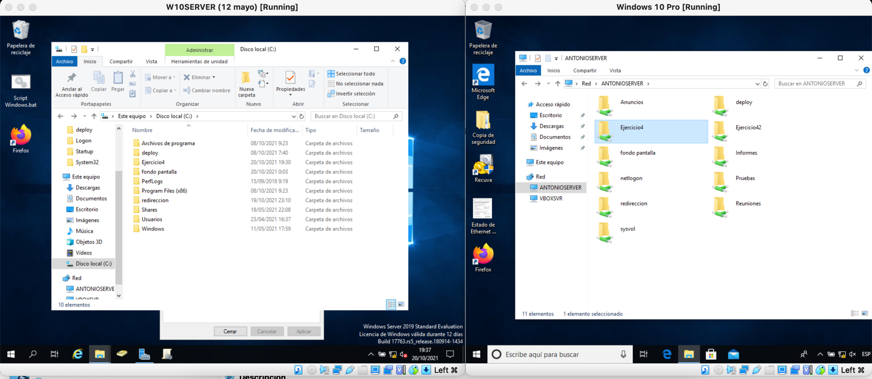

5. Adding a new AD Server to our domain.

We have to add a new server to our existing domain. We need another Windows Server

and we have to install AD DS Role, adding in it to an existing forest.

Once is set, we have to check out that is working out. We have to be able to log in our

users in the domain.

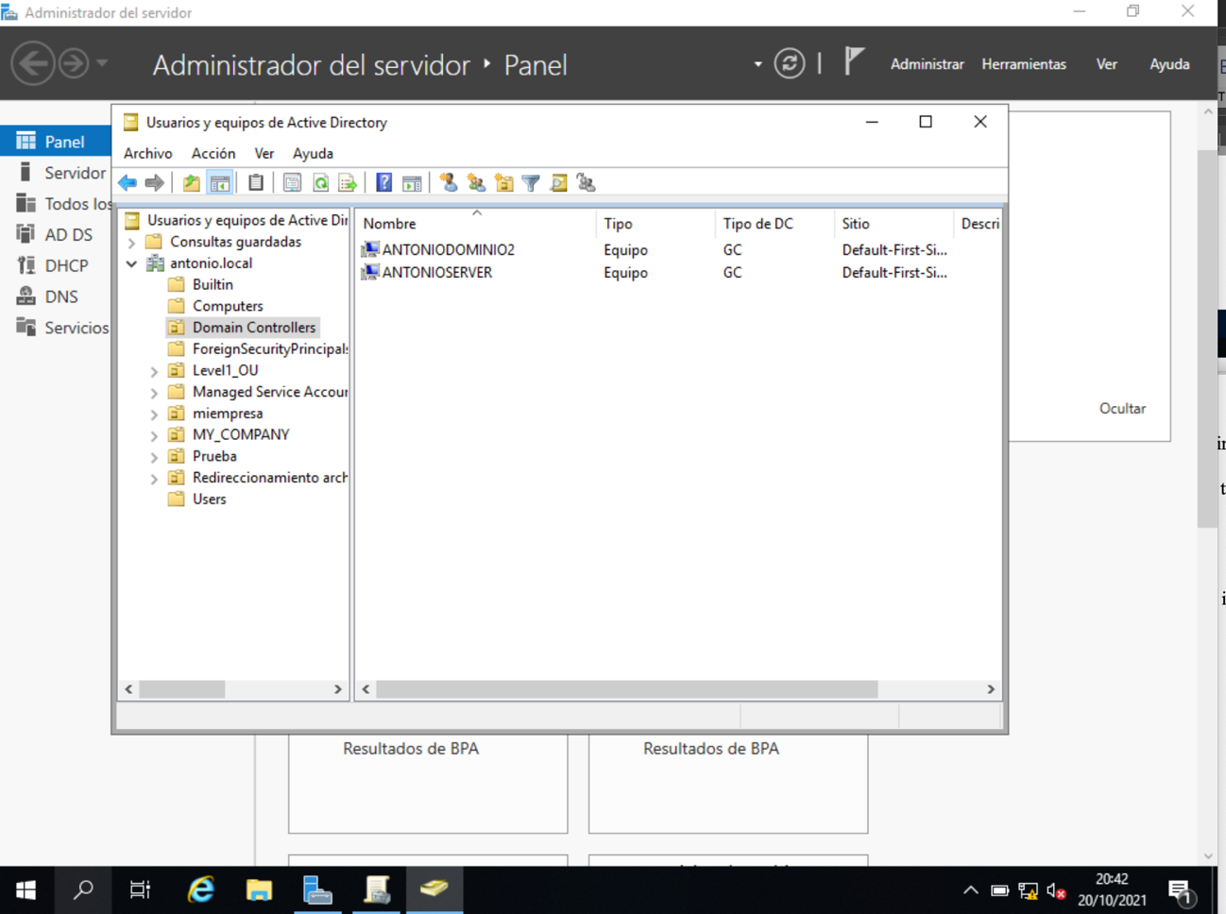

a) Add a new user “test10” to the domain from the new server. Try to log in.

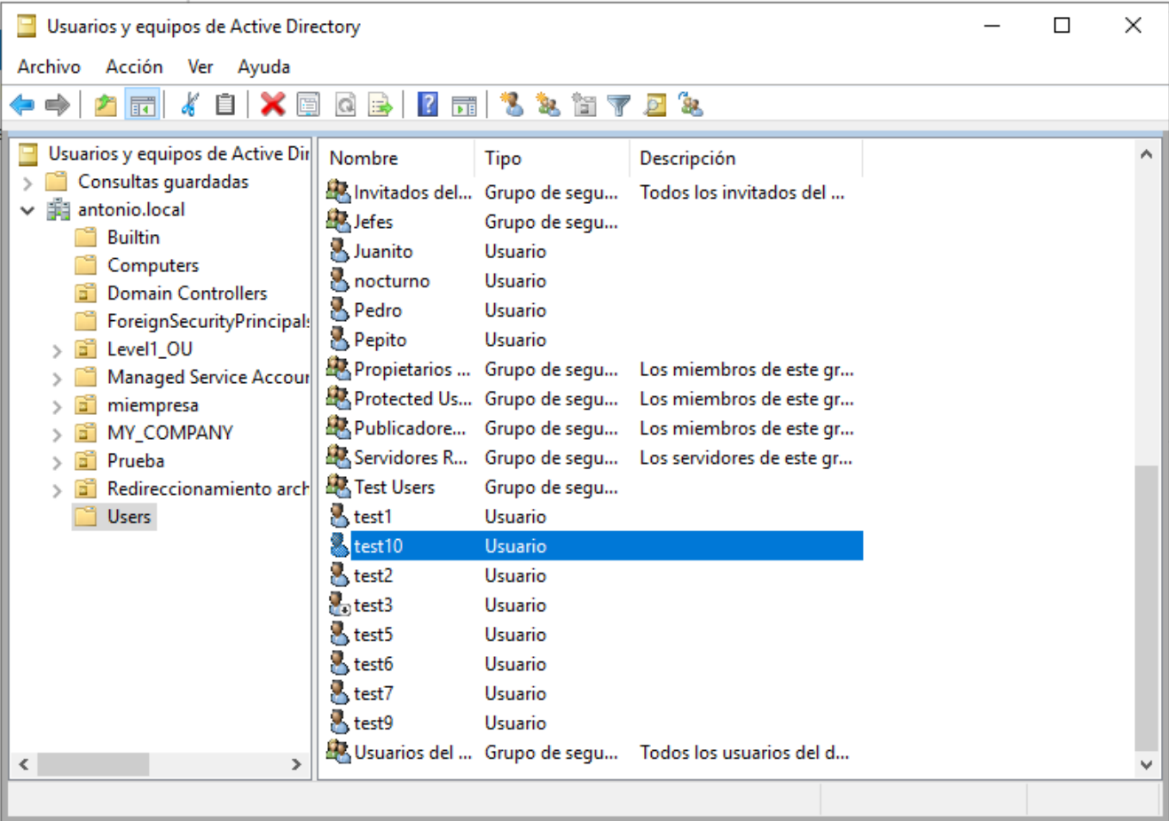

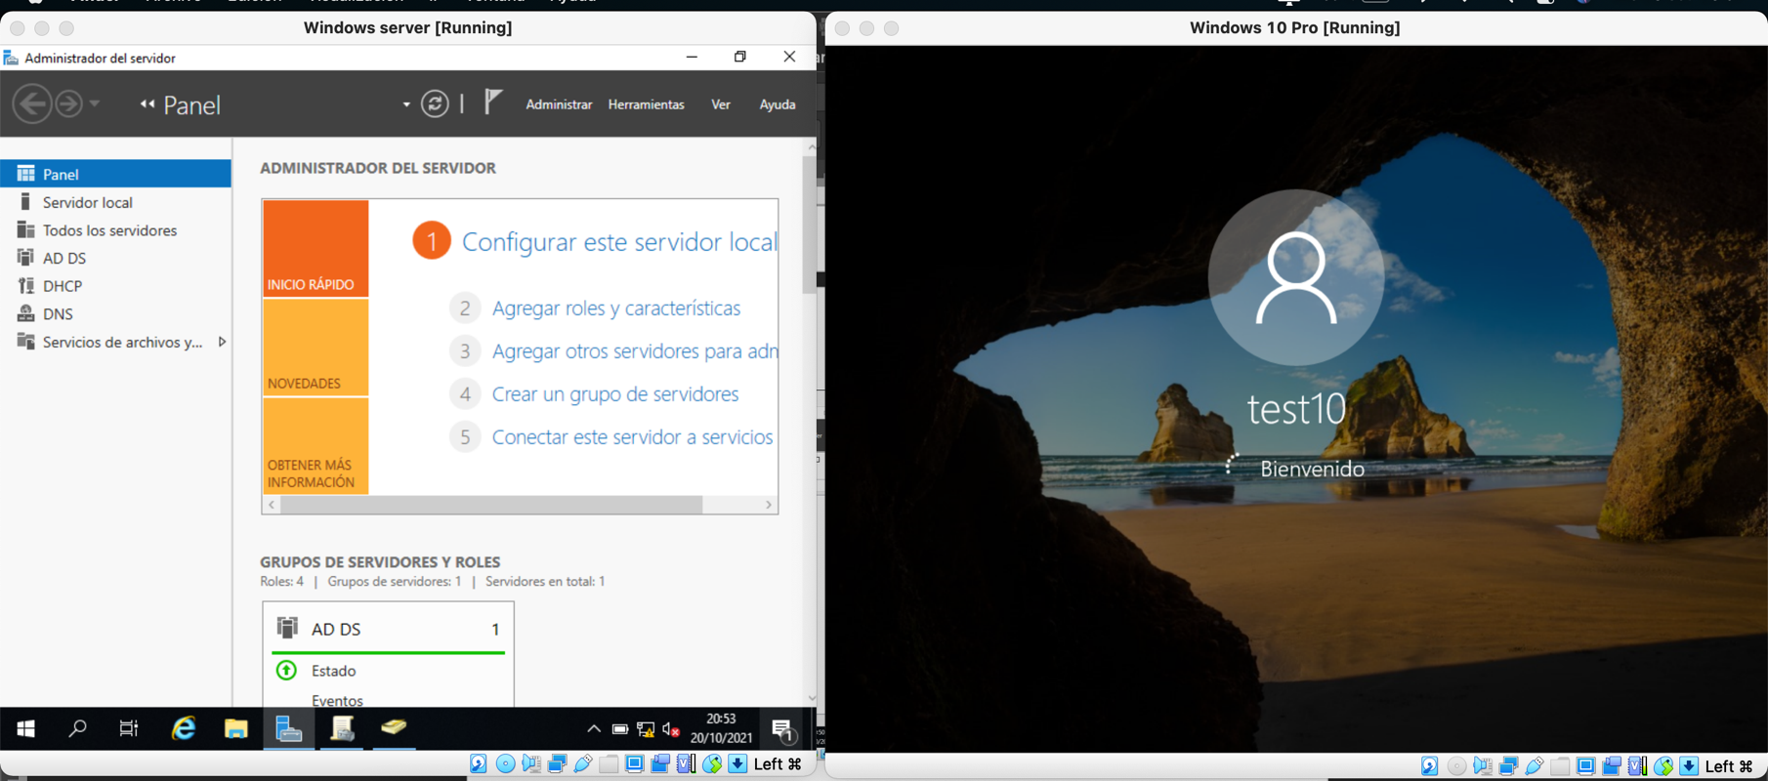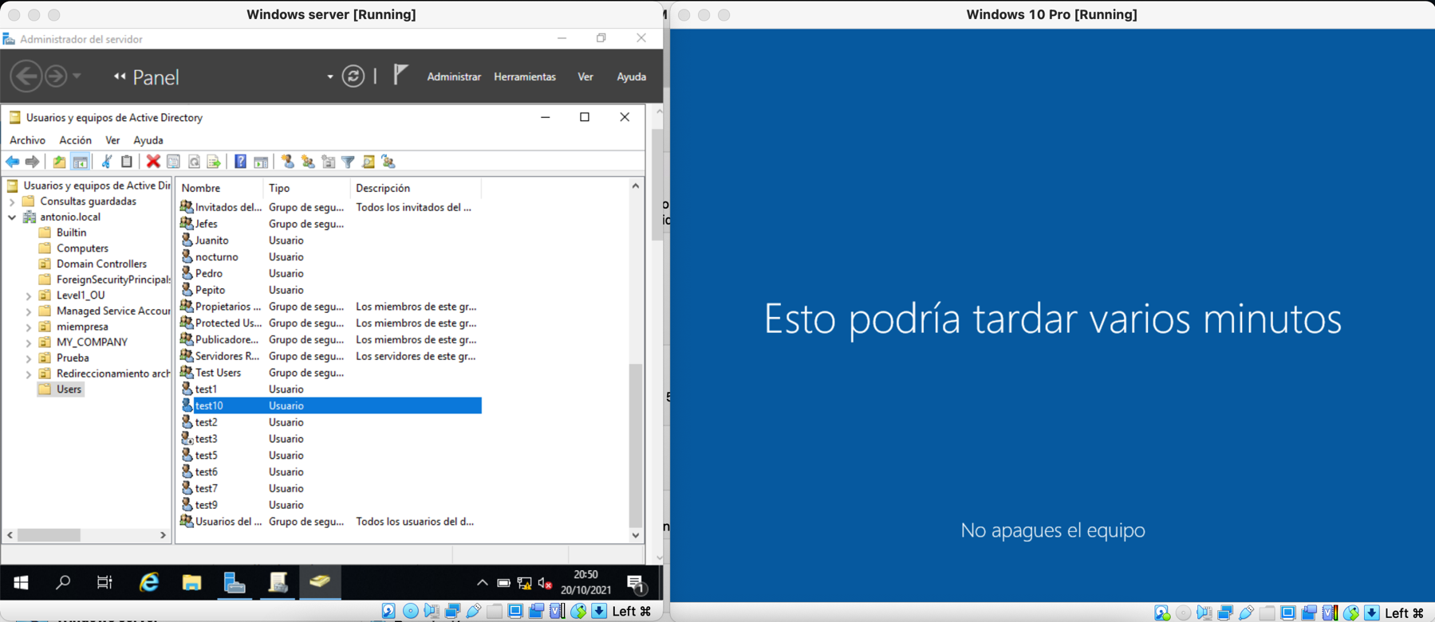

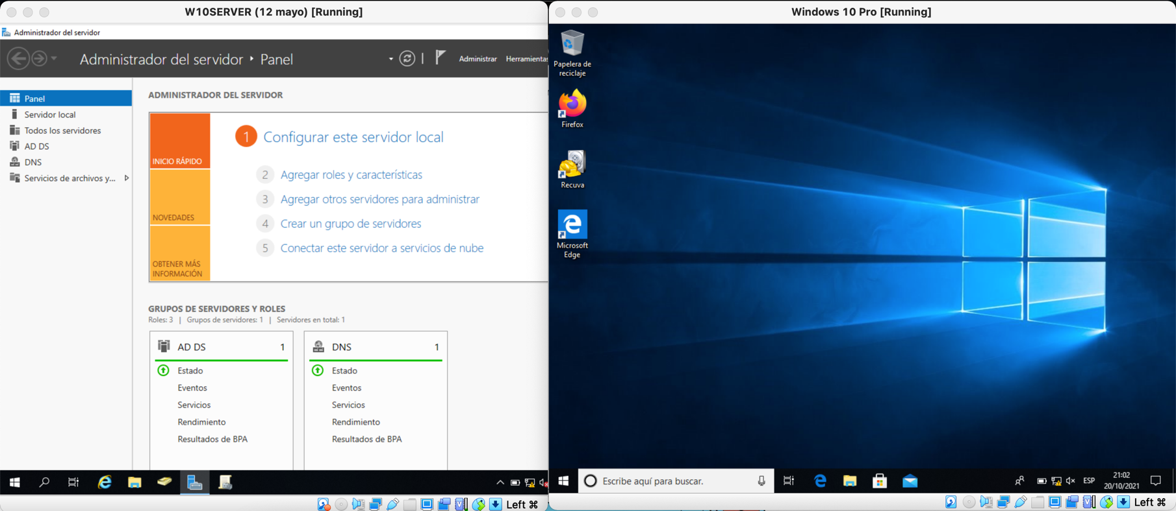b) Disconnect the first server and try to log in with test10.

c) Disconnect both servers and try to log in with test10.

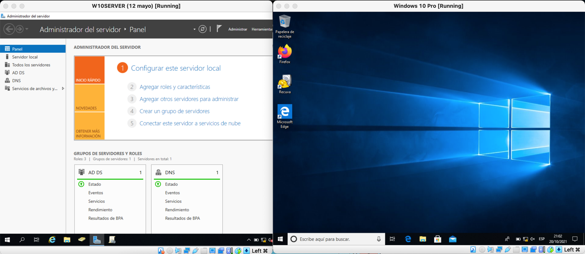

6. Restoring AD DS Role.

We have to restore our domain in a new server. We have to resport all the steps taken to

do all the activity. Where are the files to restore, what do we need to restore a domain.

I add a new hard drive to the old server to do the backup

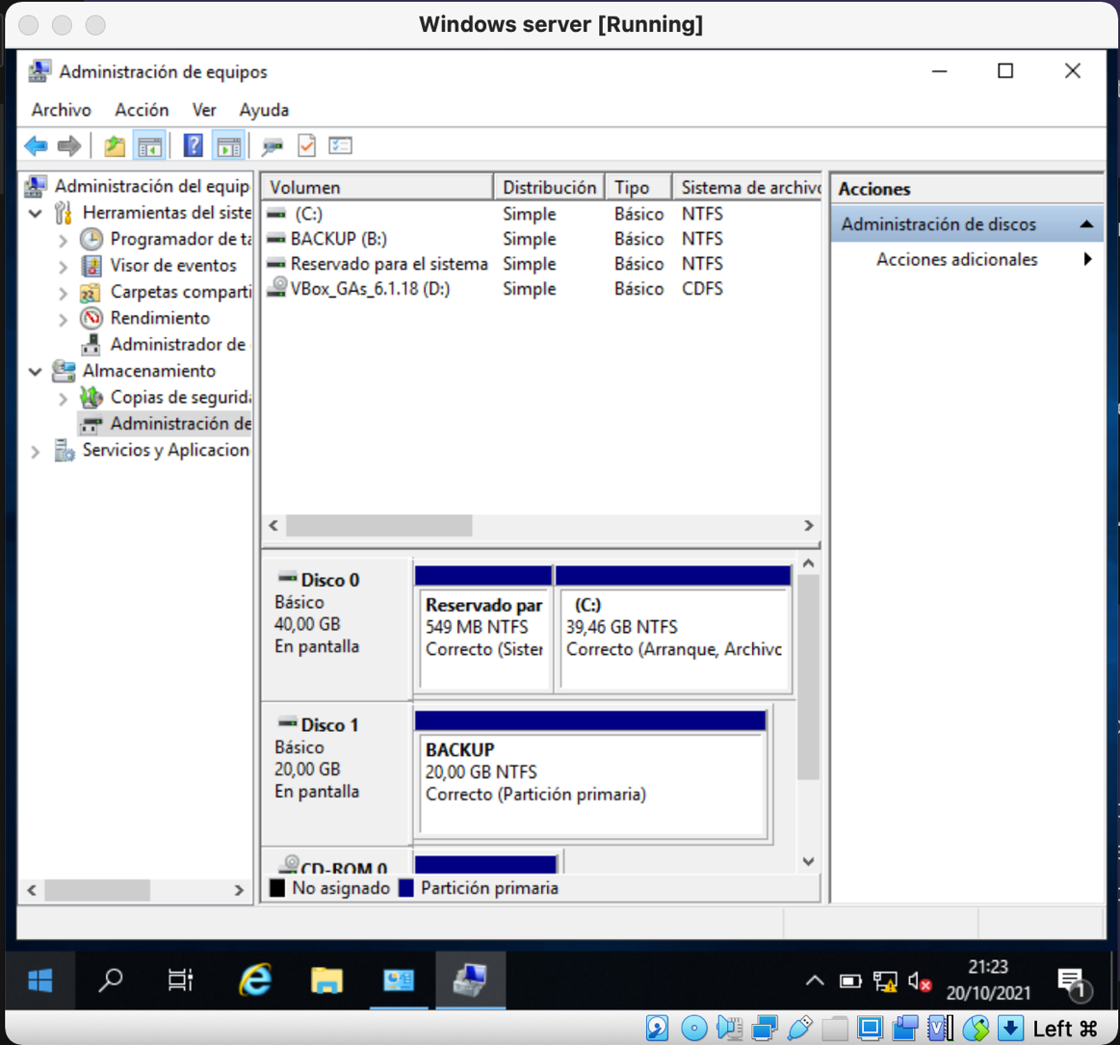

I install windows server backup feature

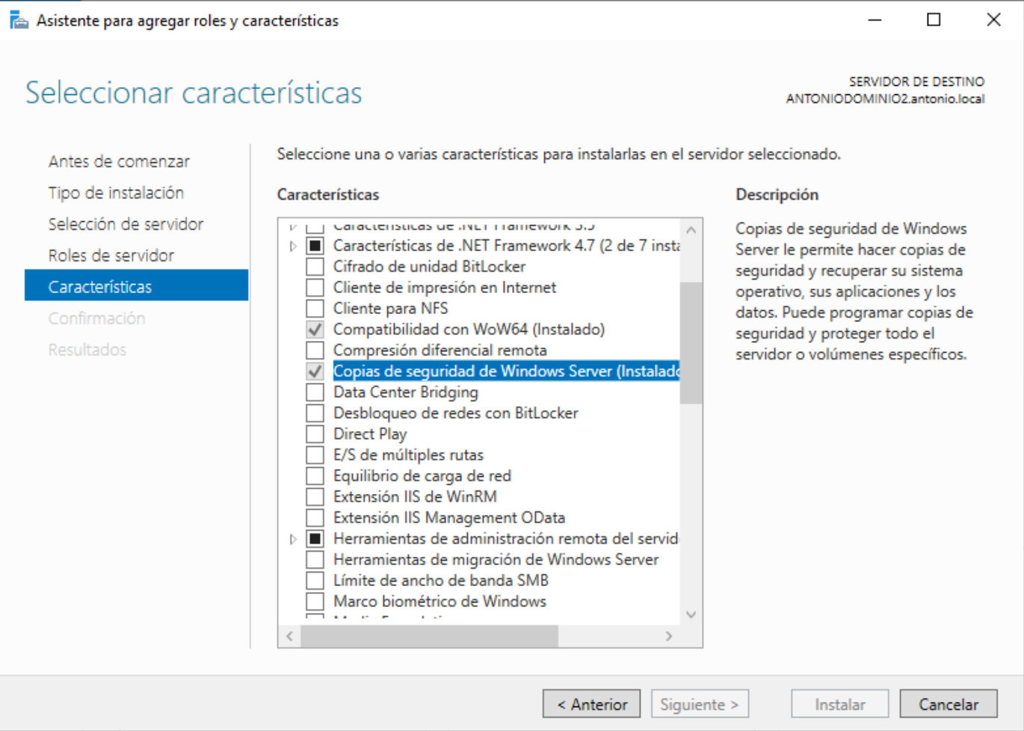

I make a backup copy of the feature that we have installed on the server

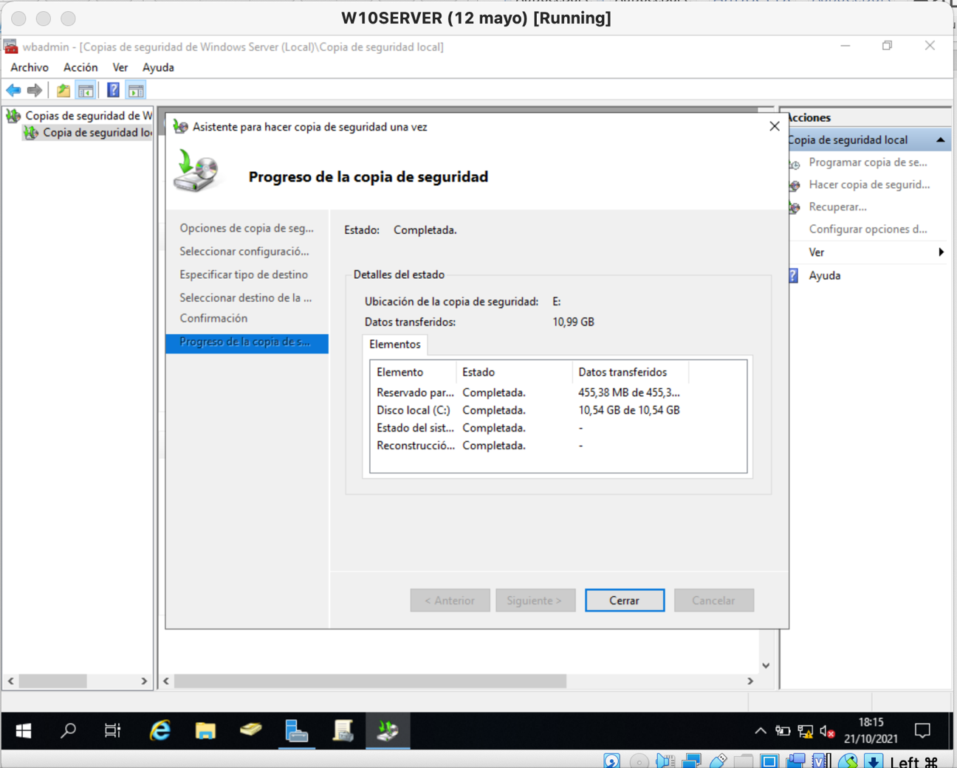

The hard disk that we have created before in the old server I share it on the network.

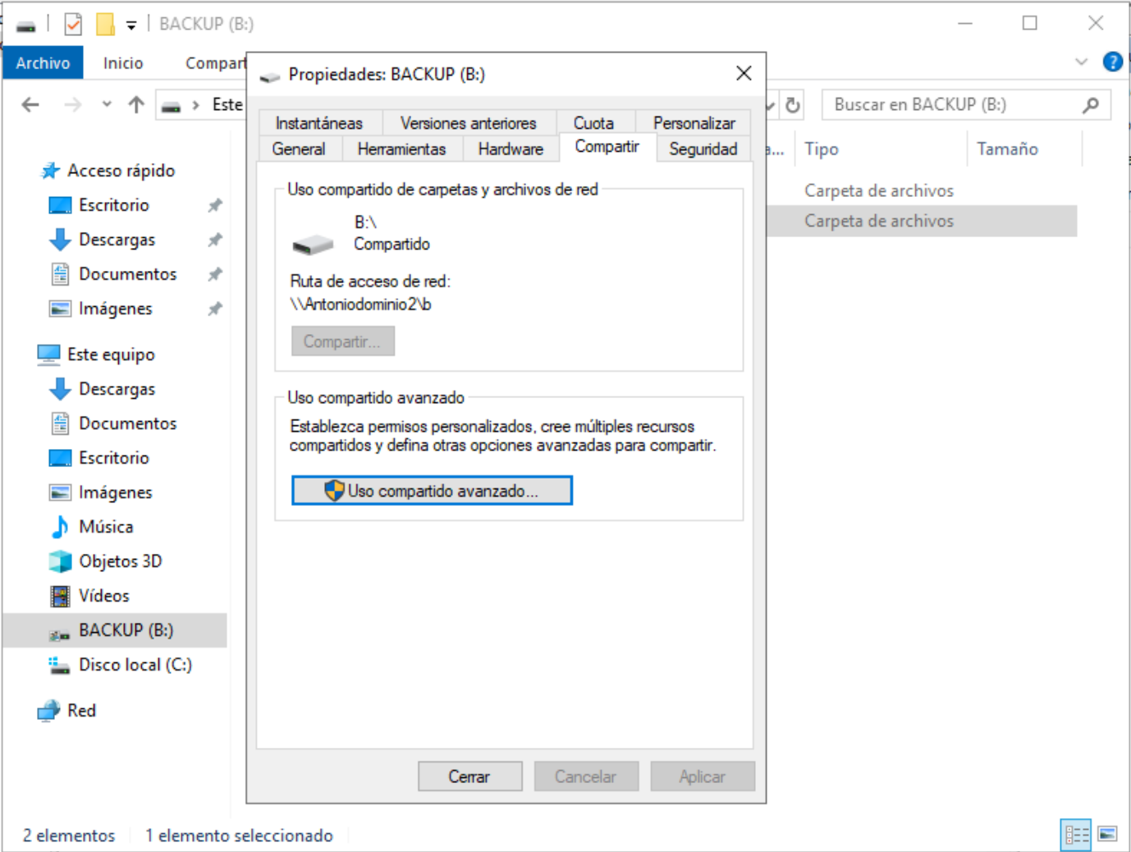

Now I go to the new server and return the backup I made on the new server to the old one.

